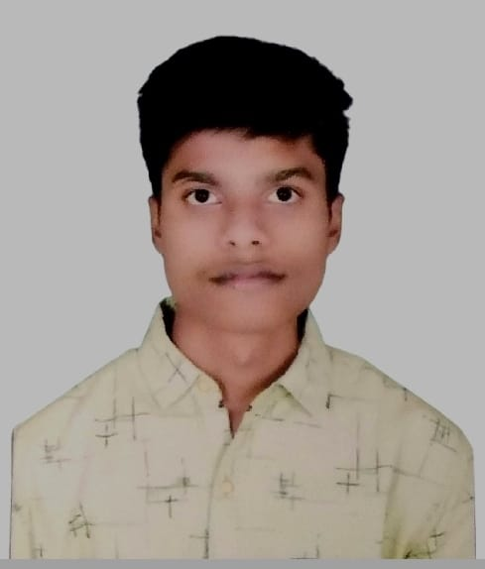 **RESUME**

**Name:**Mrunal Ramesh Somankar

**Email ID:**somankarmrunal763@gmail.com

**Contact:**7083542356

**Address:**At.Post.Ta.Chamorshi,Dist.Gadchiroli.

# CAREER OBJECTIVE

• To work with maximum potential in a challenging and dynamic environment, with an opportunity of working with diverse group of people and enhancing my professional skills with learning and experience for career growth.

**TECHNICAL PROFICIENCY**

* Languages: C++, JAVA, JAVASCRIPT, PYTHON
* Databases: SQL, My SQL
* Operating systems: Windows 10,11, Linux
* Application packages: MS Office, MS Exel, MS PowerPoint

**EDUCATIONAL QUALIFICATION**

* **Frist Year**: 9.70 SGPA (92%), Dr. D Y Patil Institute Of Technology Pimpri, Pune.
* **HSC**: 92.33%, J. K.Bomanwar Jr. Science & Arts College Chamorshi, Dist.Gadchiroli
* **SSC**: 87.20%, J. K.Bomanwar High School Chamorshi, Dist.Gadchiroli.

# PROJECT WORK

Title: Quiz using Python

Duration: 2 months

Project Description: The Project is based on the concept of letting oneself practice for subjective as well as administrative tests conducted for admissions and recruitment, with relation to Computer science and other technical fields.

**EXPERIENCE**

Fresher with leadership achievement in High School.

# PERSONAL PROFILE

|  |  |
| --- | --- |
| Father’s Name | : Ramesh Somankar |
| Date of birth | : 07 Jun 2003 |
| Gender | : Male |
| Nationality | : Indian |
| Languages Known | : English, Hindi, Marathi |
| Hobbies | : Reading Books, Playing, Exploration. |

# DECLARATION

I hereby declare that all the above-mentioned information is true to the best of my knowledge and belief.

Place:

# Date: MRUNAL SOMANKAR